|  |  |
| --- | --- |
|  | **2013** |
|  | ArbitraryY  Nick Squires |

|  |
| --- |
| **[PlTN] System Description Document (SDD)** |
| Requirements, Software/Hardware Architectures, Software/Hardware Maintenance, Installation, Operation Instructions |

Contents

Userguide 2

Updating to the Latest pltn version 2

Hardware Architecture 2

System Schematic 2

Software Architecture 3

Hardware System 4

Hardware Components Overview 4

Raspberry Pi 4

LED Driver Board 5

Arduino and Protoshield 6

Range Sensor 7

Platoon System Assembly Instructions 9

Power Supply 11

12V Power from Arduino 11

LED Strips 11

USB Connection 11

Arduino 11

Power Supply 11

Range Sensor 11

LCD Screen 11

# Hardware Architecture

## System Schematic

## 

## Hardware Listing

### Microcontrollers

* 1 x Raspberry Pi Model B
* 1 x Arduino Uno R3

### LED Driver Board

* 6 x TIP 120 Transistor
* 6 x 470 Resistor
* 1 x Adafruit Pi Plate

### Peripherals

* 1 x Edimax USB 802.11n/g/b WiFi Dongle
* 1 x 4GB SDHC Card Class 4 (already attached to RPi)
* 1 x 10K Potentiometer
* 1 x Arduino Protoplate
* 1 x Maxbotix LV-EZ1 Range Sensor
* 1 x 16x2 LCD Display
* 2 x LED Strips

# Software Architecture

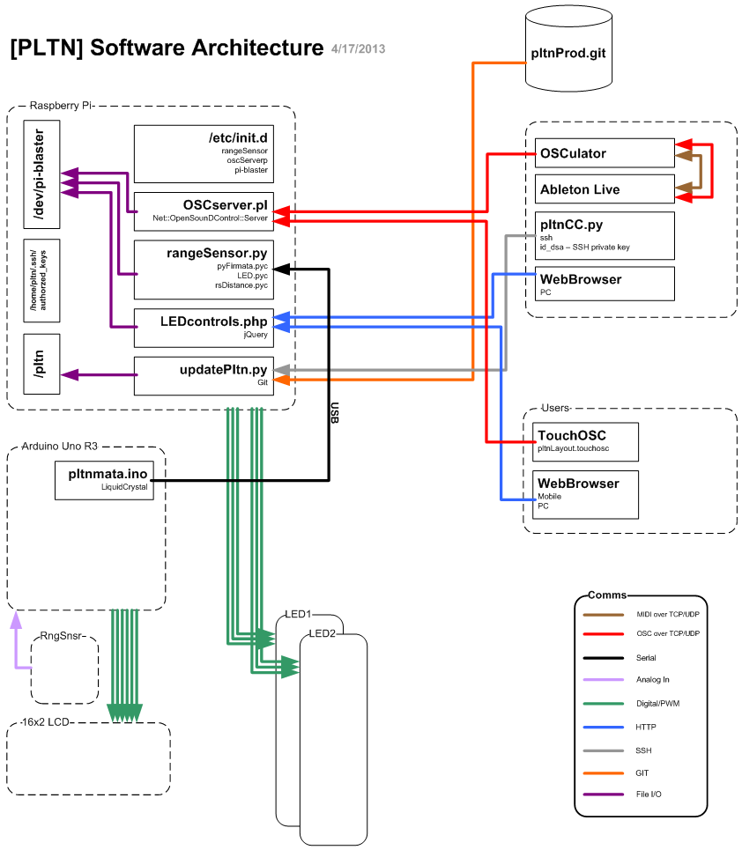

Figure - Platoon Software Architecture

# Hardware System

The following is an overview of each hardware components and their associated assembly instructions

## Hardware Components Overview

The Platoon hardware system consists of the following components

* 1 x Raspberry Pi Model B
* 1 x USB WiFi Dongle (already attached to RPi)
* 1 x 4GB SD Card (already attached to RPi)
* 1 x LED Driver Board
* 1 X Arduino Uno R3
* 1 x Arduino Protoboard (already attached to Arduino)
* 1 x 2’ USB-A to USB-B Cable
* 2 x 12V/GND wire (one black, one white)

### Raspberry Pi

The Raspberry Pi is the brain of the system. It is running the Raspbian Wheezy Linux Operating System and provides the following system functionality:

1. Webserver - Will host web based Host web applications
2. OSC Server - Accept OSC messages from Ableton (and any other OSC client) to change LED colors
3. Remote Access - SSH terminal access. Allows for remote software updates to RPi and Arduino
4. WiFi - WEP/WPA/WPA2 Network access
5. LED Controls - Software PWM to control brightness of LEDs. Change colors via webserver, OSC, or range sensor (sent over serial via Firmata from Arduino)

Below is an overview of the Raspberry Pi components you will be interested in.

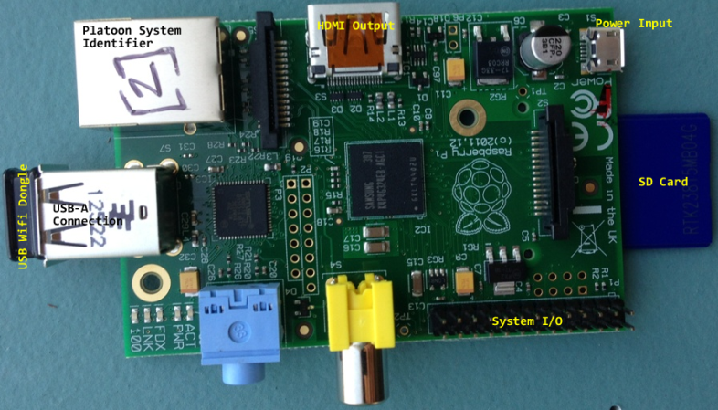

Figure 2 – Raspberry Pi Components

* Platoon System Identifier – Values range from [1] – [6] according to the associated painting
* HDMI Output – Plug in a monitor using an HDMI cable to get screen access to Raspberry Pi
* USB Wifi Dongle – WiFi access
* SD Card – Platoon system file storage and Raspbian operating system
* System I/O – System Input/Output pins. Where the LED driver board sits
* Power Input – 5.25V, 1A Micro USB-B Input

### LED Driver Board

The LED driver board is a circuit of transistors and resistors that act as power gates for the 12V LED strips. There are two circuits, one for each LED strip, and are connected via a common system ground.

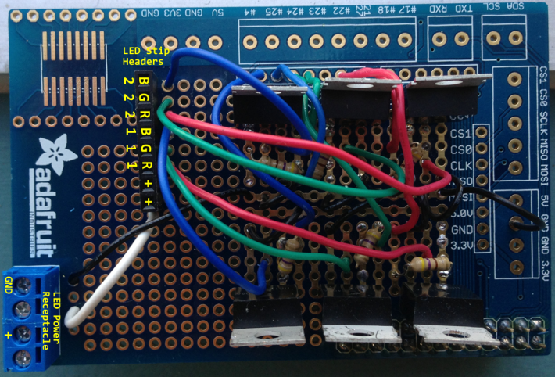

Figure 3 - LED Driver Board Overview

* LED Power receptacle – Power and common ground from the Arduino
* LED Strip Headers – Connections for LED strips
  + Rx, Gx, Bx, - Red, Green, Blue, pinouts for strip x (1|2 since 2 strips).
  + + - 12V to LED strip

### Arduino and Protoshield

The Arduino and its attached circuit board (Protoshield) provides the following system functionality:

1. Range Sensing – Detects a user’s distance from the sensor and sends data via (USB) serial connection to Raspberry Pi
2. 12V/5V power Routing – Power the LED driver board, LCD screen, and range sensor
3. LCD Control - Display painting names

Below is an overview of the Arduino and the Arduino circuit board:

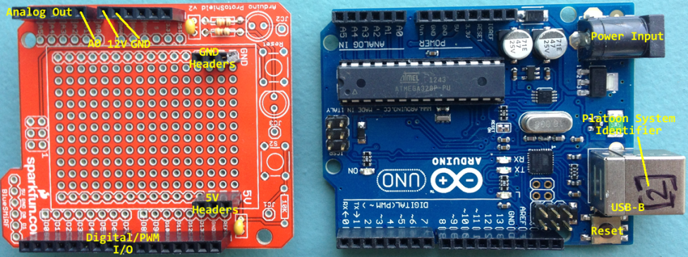

Figure 4 - Arduino and Cicuit Board

* Analog Out – Analog output pins. A0 is used for range sensor data
* 12V/GND – Supplies 12V output and common ground to LED driver board
* Digital/PWM I/O – Digital and Pulse Width Modulation (PWM) I/O pins. Provides data to LCD display.
* 5V/GND Headers – Provides power and common ground to the range sensor and LCD display
* Power Input – 12V 2A power supply connector
* Platoon System Identifier - Values range from [1] – [6] according to the associated painting
* USB–B – USB serial communications with Raspberry Pi
* Reset – Restart the Arduino

### Range Sensor

The range sensor is used to determine a user’s distance from the painting. It can use either Analog or Digital (PWM) to report distances. Below is a diagram of pertinent connections:

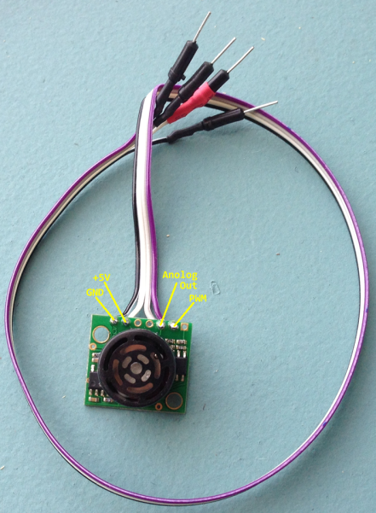

Figure 5 - Range Sensor

### LCD Screen

The Arduino takes the hardcoded value of the painting name that is embedded in the pltnmataX.ino (X is a paintings associated system identifier) code and outputs it to the LCD screen. The LCD and its pertinent connections are shown below

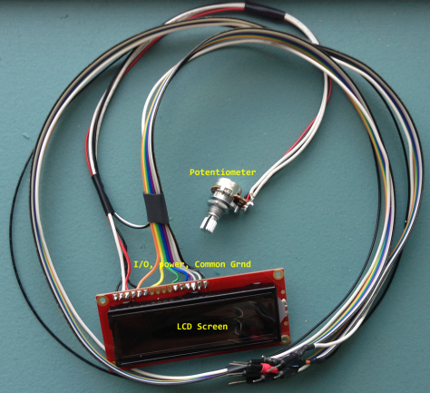

Figure 6 - LCD Screen

* Potentiometer – 10K variable resistor controls the LCD brightness
* LCD Screen – Painting name output
* I/O, Power, Common GND – Input/Output, 5V power, and common system ground connections (detailed schematic provided in “Connecting LCD to Arduino” section)

## Platoon System Assembly Instructions

1. Attach LED driver board to the system I/O pins on the Raspberry PI

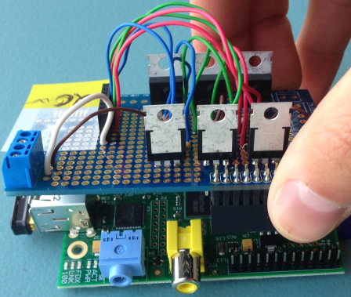

Figure 7 - LED Driver Board Attachment to RPi

1. Connect the black (GND) and white (+12V) power wires to the LED power receptacle on the LED driver board; make sure to connect the side opposite the male pin to the receptacle. Loosen the screws on the top of the receptacle, insert the wires, and then tighten screws down until they are securely fastened.

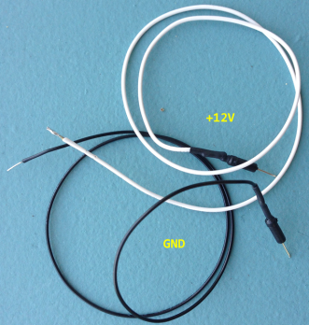

Figure 8 - Power/GND Wires

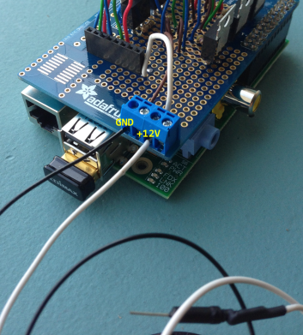

Figure 9 - Power Wire Receptacle Placement from RPi to Arduino

1. Connect the male header end of the GND/5V wires to the 5V and GND female headers on the Arduino Protoshield as shown below:
2. Connect the USB-A/USB-B cable from the Raspberry Pi to the Arduino as shown below
3. Connecting the LCD to Arduino Protoshield per the schematic below

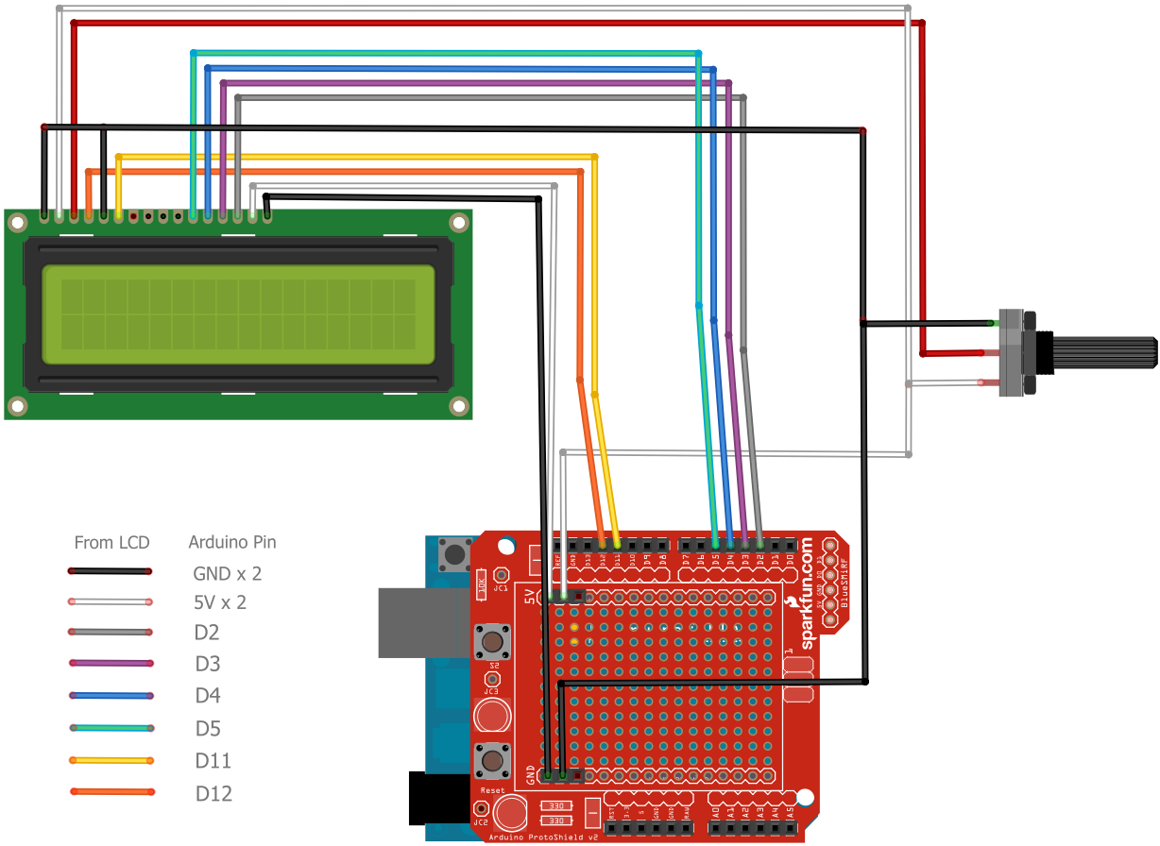

Figure - LCD --> Arduino Connections

1. Connect the LED strips to the LED driver board per the schematic below. Refer to Figure X
2. Connect the power supply to the Raspberry Pi
3. Connect the 12V power Supply to the Arduino